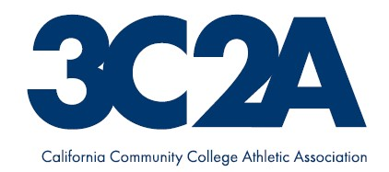
Event Contract
Sport (M/W) |  | Date(s) of Event |  | Event (N/S, Round #, ST)
Host College |  | Athletic Administrator (print) |  | Event Manager (print)
The above named understand and agree that our college, its employees, and staff will administer the above listed postconference competition event. We are familiar with the 3C2A Constitution & Bylaws and the appropriate sport championship handbook. We will abide by the 3C2A rules and regulations for this event including submitting all forms and money due within the stated timelines. Special consideration will be given to the following:
A. Preparation and submission of the proposed event budget by October 1 for fall sports (except November 1 for Basketball) and February 1 for spring sports.
B. Submission of the final financial report and check for awards and profit to the 3C2A Executive Director’s office no later than 30 days following the completion of the event or abide by the financial penalty as stated in 3C2A Bylaw 8.1.3.7.
C. The college shall indemnify and hold the CCLC, 3C2A, and their representatives harmless from all claims, damages, suits, action, or proceedings in connection with any injury or damage to any person or property related to postconference competition activities.
D. Working with the 3C2A MC Sport Representative and Office of the 3C2A Executive.
E. Working with the Sport Coaches Association President.
F. Designation of an on-site host administrator.
G. Designation of an on-site protest committee and notification to participating coaches of members of the committee.
H. Working with the sponsor(s) to provide promotional and public relations opportunities.
I. The administration of souvenir program and concession preparation and sales.
J. The administration of the awards and awards presentation for the event.
K. Submission of the Postconference Competition Evaluation, Form P, following the event.
L. The college shall provide a certified athletic trainer or appropriate medical personnel.
Should questions of event administration occur, we will refer to the 3C2A Constitution & Bylaws, the appropriate sport championship handbook, our 3C2A MC Sport Representative, the onsite protest committee, the onsite host administrator, our conference commissioner, and/or the Office of the 3C2A Executive.

President (Signature) Date Athletic Administrator (Signature) Date

Chief Business Officer (Signature) Date Event Manager (Signature) Date
Return to: CCCAA/PC Event Contract
2017 O Street, Sacramento CA 95811-5211

