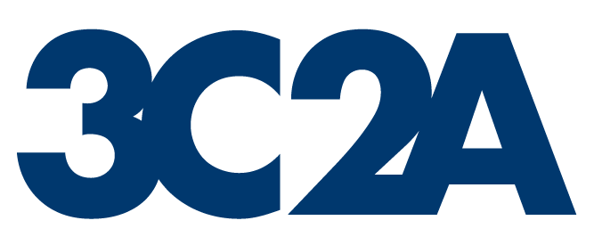 |  |  | Postconference Competition  Format Evaluation |  |  |  |  |  |  |  |  |  |  |  |  |  |  |  |  |  |  |  | Form P1
 |  |  | Sport (Indicate: Men’s or Women’s) |  |  |  |  |  |  |  |  |  |  |  |  |  |  | Year
 |  |  |  |  |  |  |  |  |  |  |  |  |  |  |  |  |  |  |  | ( )
MC Sport Representative |  |  |  |  |  |  |  |  |  | College |  |  |  |  |  |  |  |  |  | (Area Code) Phone
 |  |  |  |  |  |  |  |  |  |  |  |  |  |  |  |  |  |  |  | ( )
Coaches Association President |  |  |  |  |  |  |  |  |  | College |  |  |  |  |  |  |  |  |  | (Area Code) Phone
3C2A Regionals
Format Description:
Number qualifying to: North |  |  |  |  |  |  |  |  |  |  |  | South |  |  |  | Financed by
North:
 | Site(s) |  |  |  |  |  |  |  |  |  |  |  |  |  |  |  |  |  |  | Date(s)
 |  |  |  |  |  |  |  |  |  |  |  |  |  |  |  |  |  |  |  | ( )
Event Manager(s) |  |  |  |  |  |  |  |  |  | College |  |  |  |  |  |  |  |  |  | (Area Code) Phone
South:
 | Site(s) |  |  |  |  |  |  |  |  |  |  |  |  |  |  |  |  |  |  | Date(s)
 |  |  |  |  |  |  |  |  |  |  |  |  |  |  |  |  |  |  |  | ( )
Event Manager(s) |  |  |  |  |  |  |  |  |  | College |  |  |  |  |  |  |  |  |  | (Area Code) Phone
3C2A State Championship
Format Description:
Number qualifying from Regionals to State Championship:
North |  |  |  |  |  |  |  |  |  |  | South |  |  |  |  | Financed by
Site(s) |  |  |  |  |  |  |  |  |  |  |  |  |  |  |  |  |  |  |  | Date(s)
Event Manager(s) |  |  |  |  |  |  |  |  |  | College |  |  |  |  |  |  |  |  |  | (Area Code) Phone
Date of Last PC Change |  |  |  |  |  |  |  |  | Date of Last Sport Championship Handbook Change
Recommendations for Change:
 |  |  |  |  |  |  |  |  |  |  |  |  |  |  |  |  | Effective Date
Return to: |  | Form P1 ♦ CCCAA ♦ 2017 O Street♦ Sacramento, CA 95811-5211 |  |  |  |  |  |  |  |  |  |  |  |  |  |  |  |  |  |  |  |  |  | (7/1/24)

