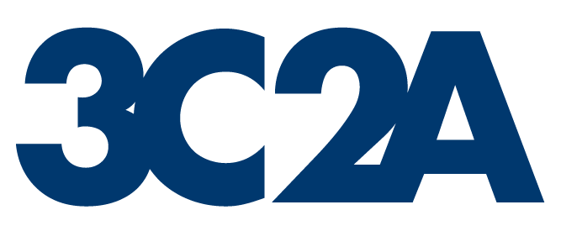 | Vote on Change of Athletics  Conference Membership |  |  |  |  |  |  |  |  |  |  |  |  |  |  |  | Form N
This form is to be completed by the conference commissioners of Conferences A & B. One vote is to be cast by each college president within both conferences and their votes tallied on this form. After Conference A completes their section of the form, they shall send it to the commissioner of Conference B to complete. The completed form is to be forwarded to the appealing college president, college presidents of both conferences, and the 3C2A Executive Director by the 2nd Friday in May.
Conference A: Present Conference
Name of Conference A |  |  |  |  |  | Board Rep or Commissioner’s Signature |  |  |  |  |  |  |  |  |  | Date
Total Vote of Conference A: |  |  | Approve |  |  |  |  |  | Deny |  |  | Abstain
Conference Recommendation:
Conference B: Conference in which membership is requested
Name of Conference B |  |  |  |  |  | Board Rep or Commissioner’s Signature |  |  |  |  |  |  |  |  |  | Date
Total Vote of Conference B: |  |  | Approve |  |  |  |  |  | Deny |  |  | Abstain
Conference Recommendation:
To be completed by the 3C2A Executive Director’s Office:
3C2A Recommendation:
Executive Director’s Signature |  |  |  |  |  |  | Date
(7/1/24)

