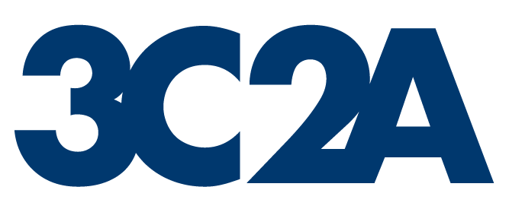 |  | Request for  Sport Augmentation Funds  Submit completed form to:  Sport Augmentation Request  3C2A  2017 O STREET  Sacramento, CA 95811-5211 |  |  |  |  | Form D
This form must be submitted no later than three weeks prior to the 3C2A meeting before the season of the planned activity. The 3C2A Board shall consider requests at its 3C2A Board meeting.
 | Sport |  |  | Site |  | Date of Event
 | Event Manager |  |  | Submitted by |  | $ Amount Requested
List below the budget plan for your postconference competition, asterisk (*) items that would be eliminated from the budget without support from the Sports Augmentation Account. Include your proposed budget with this form.
Estimated Income: (Main headings; i.e., ticket sales, sponsor)  Source:  1.  2.  3. | Amount:  $  $  $  Total: | $
Estimated Expenses: (Main headings; i.e., game administration, awards)  Item:  1.  2.  3.  4.  5. | Cost:  $  $  $  $  $  Total | $
Amount Requested: |  | $
Note: These funds are to be returned to the Sports Augmentation Account before any reimbursements are made. (These funds should not be considered income—they are an expense.)
Signature, Event Manager |  | Signature, 3C2A Sport Representative
College |  | Date Submitted

(7/1/24)

