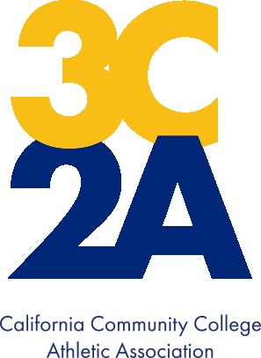

3C2A
Student-Athlete
Celebratory Signing Form

Name of Student-Athlete: ___________________________________________________________________
LAST FIRST MI

Permanent Address: _______________________________________________________________________
STREET CITY STATE ZIP CODE

Sport(s) _______________________________ College: _________________________________________

Congratulations on pursuing your academic and athletic goals at the collegiate level. This form is intended to be used by prospective
student-athletes that are interested in joining a California Community College Athletic Association (3C2A) member institution at any point, including high school and/or club team signing events.

Please sign below during your signing event:

______________________________________________ ________________________
PROSPECTIVE STUDENT-ATHLETE DATE

______________________________________________ ________________________
PARENT/LEGAL GUARDIAN DATE

______________________________________________ ________________________
HEAD COACH DATE

Please note that this form is non-binding and intended to be used for celebratory signing purposes only. The prospective student-athlete may change their mind and attend another college. Other colleges may still recruit the prospective student-athlete, regardless of whether they have signed the form.

