CALIFORNIA COMMUNITY COLLEGE ATHLETIC DIRECTORS ASSOCIATION
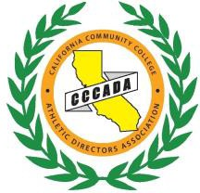
CCCADA Executive Board
Kulwant Singh, De Anza – President
Randy Totorp, Saddleback – 1st Vice President
Brent Davis, Sequoias – 2nd Vice President
Kanoe Bandy, Taft – Treasurer
Dan Clauss, Saddleback – Ex-Officio Past President
http://www.cccaasports.org/cccada/index Address: Taft College 29 Cougar Court Taft, CA 93268

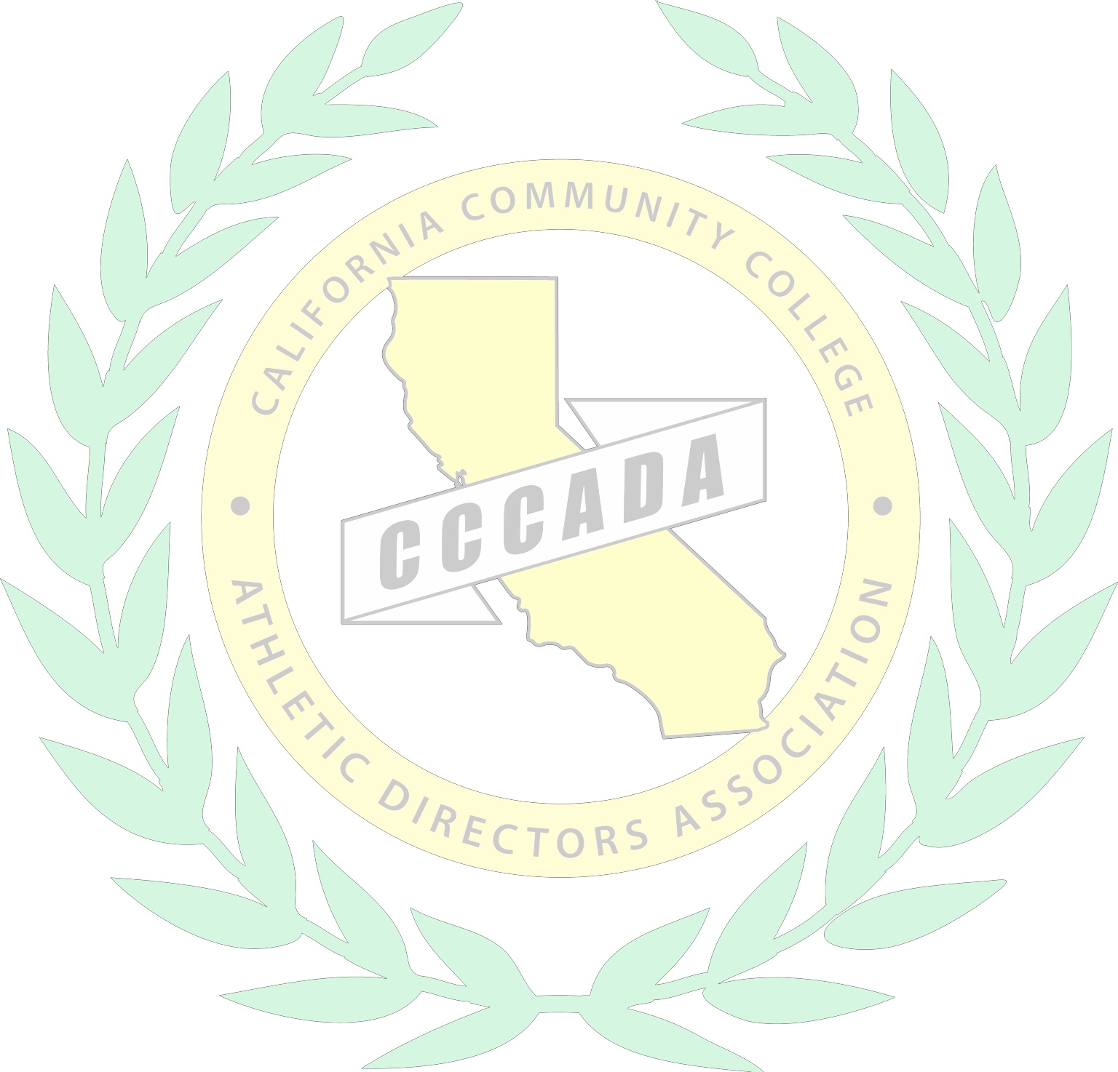
CCCADA BUSINESS MEETING NOTES
Concord Hilton – Golden Gate AB Thursday, November 7, 2019
10:30 AM – 12:00 PM A G E N D A

- Call to Order
  - 10:34 am called to order.

- Welcome
  - Introduction of new members or those who have changed colleges
    - New AD’s went to front and introduced themselves. List of new AD’s are on Exec Board minutes.
  - Executive Officers & Board Conference Reps Introductions
  - Retiring Athletic Directors.
    - Steve Hebert- Rio Hondo, Sandi Taylor- Bakersfield,
  - Conference representatives introduced.

- Additions to the Agenda

- Approval of the Agenda

  - First, Second, Approved

- Approval of Minutes
  - 2019 CCCADA Summer Meeting –Tahoe (decision)
    - First, Second, Approved

- Treasurer’s Report – Kanoe Bandy (information)
  - Financial Report
    - Kanoe noted sponsorship records set. 27k in sponsorship but in reality some sponsors paid for social activities. Sponsorship dollars were more around 38k.
  - Membership & Dues
    - 119 members representing 88 schools last year. Currently 72 members representing 56 schools.
  - Sponsorships
    - See above.

- Cal Pass Update- Andreas Wolf
  - Informed membership he could be point of contact for help if anyone needs it. It is now part of program review so get familiar with software.

- CCCPE Update – Andreas Wolf
  - CCCPE group met this morning. Wolf discussed history of CCCPE. Plan is for faculty members involved and build it up from there. “Why” we need CCCPE was discussed. “White paper” launching the plan to get organization going will be created by work group lead by Wolf. There was money from CCCPE available from when it dissolved and those funds will help launch the organization.

- One Love Foundation – Andreas Wolf
  - Wolf challenged all CCCAA schools to have One Love on their campus during the 2020 calendar year. Workshops do not cost money. One Love will train our student-athletes. Wolf asked for support of the membership to hold workshops.

- CCCAA Executive Director Position Update
  - CCCAA Board has created committee to hire interim CEO. That committee will organize it to launch the job. Discussion on the process of getting both the interim and permanent position rolled out took place.

- Old Business (information)
  - Tahoe Convention Update – Randy Totorp
    - Randy solicited membership for topics for Tahoe. Update on sponsorship was discussed.
    - Ron Hannon asked if we can add an “in-kind” line item on our financial report. Lots of “in-kind” donations were received by CCCADA.
b. Dates June 2, 2020-June 4, 2020
- Hotel deadline 5/1/20
- Sponsors Update
  - See above.
- Golf/Fishing Update – Steve Hebert & Ron Hannon
  - Fishing is Tuesday morning. Email Hebert with interest. Hannon discussed golf – Wednesday afternoon is golf. 88 players last year. Lots of sponsors in that group. Mid 50’s the year before. Membership will be responsible for rental clubs moving forward. Rental clubs will be reflected on the registration form.
- Coaches vs. Cancer Update- Jonas Crawford
  - CCC’s have raised over 300k since 2011. Jonas taking over Southern California coordination of this operation. Mendoza up north.
- NACDA/NATYCAA Update- Joe Jennum
  - June 7-10 in Las Vegas. There is a grant available for first time attendees.

- New Business
  - First call for Second Vice President Nomination-South
    - Gary Plunkett College of the Desert, John McHenry Cerro Coso College have been nominated. Spring vote will occur.
  - Announce Management Council reps and application process
    - MW Tennis filled by Colin Preston, El Camino
    - Men’s Basketball, MW Cross Country, MW Soccer, & Men’s Volleyball.
      - Kulwant discussed application process. Application is on ADA website.
  - Women’s Wrestling
    - Goal was to launch sport in Spring of 2021.
  - ADA Communication Liaison
    - Randy discussed how this concept came to reality. Randy solicited for interested candidates. Melanie Stockwell has been appointed as the ADA liaison.
  - CCCAA Student Athlete Survey
    - Randy pointed out that CCCAA spent a lot of money on hiring SDSU to create and administer survey. It has not rolled out smoothly. Randy called on AD’s to get the survey link out.

- CCCAA Legislation Discussion
  - Emergency legislation pulled for discussion.
    - P-11: Division 3 football impacts CCCAA eligibility. Straw poll showed CCCADA supported this legislation.
    - P-31 Bat testing – Wolf voiced concern about the application of this rule. Who will do the bat testing? Issues with the language and who does the testing. General comments were they wanted the umpires involved. Straw poll showed more against the legislation.
    - O-2 straw poll showed support.

- Good of the Order

- Adjournment – 12:04pm

